MIT WORLD PEACE UNIVERSITY

TYBTECH, Sem- 1

Full Stack Development (FSD)

ASSIGNMENT 2-

Design and develop a responsive web page

using Bootstrap front end framework

PA-17

SAYYAM SABOO

BATCH-A1

# Aim:

Design and develop a responsive web page using Bootstrap front end framework.

# Objectives:

1. To understand HTML tags
2. To learn the styling of web pages using CSS
3. To learn Bootstrap Front End Framework.

# Theory:

1. **Bootstrap Grid System.**

The Bootstrap Grid System stands as a foundational element within the Bootstrap framework, a widely adopted open-source front-end framework tailored for web development. It introduces a responsive grid structure that streamlines the creation of mobile-first web layouts. Below are key insights into the Bootstrap Grid System:

1. Grid Structure: Bootstrap employs a 12-column grid framework, segmenting web page content into 12 equally sized columns. Developers leverage these columns to configure the page layout.
2. Responsiveness: The Bootstrap grid is inherently responsive, automatically adjusting to diverse screen dimensions and device types. This adaptability ensures seamless website performance on both desktop and mobile platforms, achieved through the integration of media queries and CSS classes.
3. Mobile-First Philosophy: Bootstrap adheres to a mobile-first design philosophy, meaning it initially caters to mobile devices and progressively enriches the layout for larger screens. This strategy guarantees an appealing appearance on smaller displays without extensive custom CSS.
4. Grid Classes: Bootstrap furnishes an array of grid classes for crafting column-based layouts. Typically named 'col-' followed by the desired column count, these classes enable precise control. For example, 'col-12' spans the container's entire width, while 'col-md-6' occupies half the width on medium-sized screens.
5. Container Options: Bootstrap offers two primary container classes – 'container' and 'container-fluid.' 'Container' enforces a fixed width, while 'container-fluid' extends across the full viewport width.
6. Grid Nesting: The framework permits nested grids, empowering the creation of intricate layouts within existing columns.
7. Column Offsetting: Bootstrap features offset classes, facilitating spacing adjustments between columns.
8. Column Ordering: Developers can manipulate column display order using order-specific classes, affording flexibility in layout arrangement.
9. Visibility Control: Bootstrap integrates classes for toggling content visibility on specific screen sizes, simplifying the creation of responsive designs.

# Bootstrap .container and .container-fluid class.

In Bootstrap, the **.container** and **.container-fluid** classes serve as vital elements responsible for encapsulating and structuring the content within a web page. These container classes play a fundamental role in the grid system, facilitating precise control over layout and responsiveness. Let's delve into each of these classes:

1. **.container Class:**
   * The **.container** class establishes a container with a fixed width, ensuring a responsive layout adaptable to diverse screen sizes. However, it imposes a maximum width constraint to prevent excessive width on larger screens.
   * This class dynamically adjusts the container's width based on the viewport size. On smaller screens, it occupies the entire viewport width, while on larger displays, it confines the content within a well-centered and easily readable area.
   * The **.container** class proves invaluable in designs aiming for a controlled content width, guaranteeing both readability and aesthetic appeal.

Example usage:

htmlCopy code

<div class="container">

<!-- Your content goes here -->

</div>

1. **.container-fluid Class:**
   * The **.container-fluid** class creates a full-width container, extending across the entire viewport width. It's particularly effective when content needs to span the entire horizontal expanse of the screen.
   * Unlike the **.container** class, **.container-fluid** lacks a maximum width constraint, making it suitable for designs demanding content to occupy the entire viewport width.

Example usage:

htmlCopy code

<div class="container-fluid">

<!-- Your content goes here -->

</div>

When choosing between these container classes, consider the specific design and layout requirements of your web page. Opt for the **.container** class when you seek to maintain a maximum content width, ensuring readability and precise design control. Conversely, employ the **.container-fluid** class when your design calls for content to span the entire screen width.

It's important to note that the choice between these container classes represents just one facet of crafting responsive layouts in Bootstrap. As previously mentioned, the grid system plays a pivotal role in organizing content within these containers to achieve responsive and visually appealing web designs.

# FAQ:

1. **What is a responsive website?**

A responsive website is meticulously crafted to seamlessly adapt and present its content flawlessly across an array of screen sizes and devices, encompassing desktop computers, laptops, tablets, and smartphones. This adaptability is paramount because each device possesses distinct screen dimensions and resolutions. A responsive website masterfully orchestrates its content, layout, and overall design to dynamically accommodate and optimize the user experience on any device.

Key attributes defining a responsive website encompass:

1. **Fluid Layout:** The website's layout is ingeniously designed to effortlessly expand or contract, harmonizing with the screen's width, regardless of the device in use.
2. **Flexible Images and Media:** Visual elements, including images and media components like videos and maps, undergo artful adjustments to snugly fit the screen dimensions, eliminating distortion.
3. **Media Queries:** Employing CSS media queries, the website tailors specific styles and layouts according to the screen size or unique device features, ensuring a tailored presentation.
4. **Touch-Friendly Design:** With touchscreens prevalent on devices such as smartphones and tablets, the website incorporates touch-friendly elements and intuitive gestures, fostering seamless navigation and interaction.
5. **Optimized Content:** Content is thoughtfully curated, possibly prioritized, concealed, or reorganized to ensure pivotal information commands attention on smaller screens, preserving user engagement.
6. **Cross-Browser Compatibility:** The website consistently functions across a spectrum of web browsers, ensuring uniformity in user experience regardless of the platform.

A responsive website elevates user experience, diminishing bounce rates, and augmenting SEO performance, as esteemed search engines like Google hold a preference for mobile-friendly, responsive design

# How Bootstrap helps to design a responsive website?

Bootstrap stands out as a renowned front-end framework, revolutionizing the creation of responsive websites. It wields a profound influence in the realm of responsive web design through the following facets:

1. **Grid System:** At the core of Bootstrap lies a versatile 12-column grid system. This grid system empowers designers to craft responsive layouts effortlessly. You have the liberty to specify how many columns an element should span on diverse screen dimensions, ensuring precise content placement.
2. **Responsive Utilities:** Bootstrap boasts a repertoire of responsive utility classes and predefined breakpoints. These tools grant you the ability to control element visibility, manage display on various screens, or fine-tune attributes like font size for mobile devices. For instance, you can discreetly conceal a sidebar on smaller screens or tailor font sizes for enhanced readability on mobile gadgets.
3. **Pre-Designed Components:** The treasure trove of Bootstrap extends to a library replete with pre-designed, responsive components. These components encompass navigation menus, modals, carousels, and more, all meticulously crafted to seamlessly adapt to an array of screen sizes.
4. **Mobile-First Philosophy:** Bootstrap adheres to a mobile-first design philosophy, prioritizing optimization for smaller screens. Subsequently, it progressively enhances the user experience for larger displays. This approach ensures that your website exudes excellence on mobile devices without necessitating intricate custom coding.
5. **Built-In CSS:** Bootstrap's CSS is a paragon of cross-browser compatibility and responsiveness. This inherent adaptability significantly mitigates the need for arduous, browser-specific fixes, streamlining the development process.
6. **Robust Documentation:** Bootstrap further distinguishes itself by offering comprehensive documentation and illustrative examples. This wealth of resources empowers developers to grasp and implement responsive design principles with ease.

By harnessing Bootstrap, web developers unlock the power to economize time and effort in constructing responsive websites. It furnishes a structured framework that simplifies the design and development journey, culminating in uniform, aesthetically pleasing web layouts across a diverse landscape of devices and screen dimension.

Responsive Utilities: Bootstrap includes responsive utility classes and predefined breakpoints that allow you to hide, show, or adjust elements based on the screen size. For example, you can hide a sidebar on smaller screens or change the font size for mobile devices.

Pre-Designed Components: Bootstrap offers a library of pre-designed responsive components, such as navigation menus, modals, and carousels. These components are designed to work seamlessly on various screen sizes.

Mobile-First Approach: Bootstrap follows a mobile-first design philosophy, meaning that it's optimized for small screens and progressively enhanced for larger screens. This approach ensures that your website looks good on mobile devices without additional custom coding.

Built-In CSS: Bootstrap's CSS is optimized for cross-browser compatibility and responsiveness, reducing the need for extensive browser-specific fixes.

Extensive Documentation: Bootstrap provides thorough documentation and examples, making it easy for developers to understand and implement responsive design principles.

By using Bootstrap, web developers can save time and effort in creating responsive websites, as it provides a framework that simplifies the design and development process, resulting in consistent and visually appealing web layouts across a wide range of devices and screen sizes.

# Output:

Made a Stationary Shop website using Bootstrap.

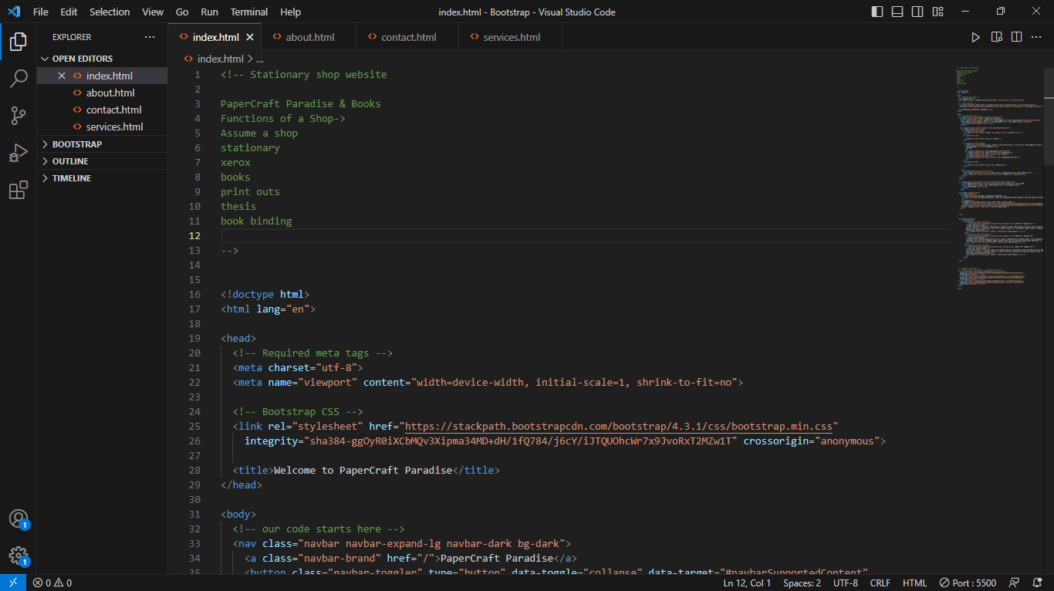 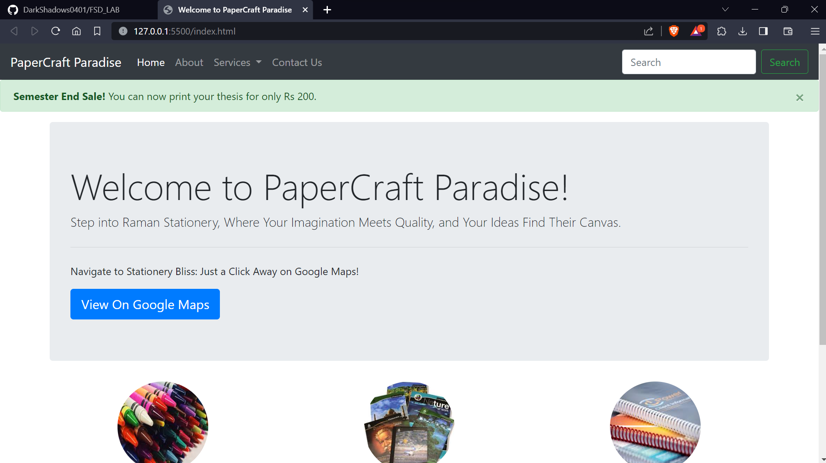



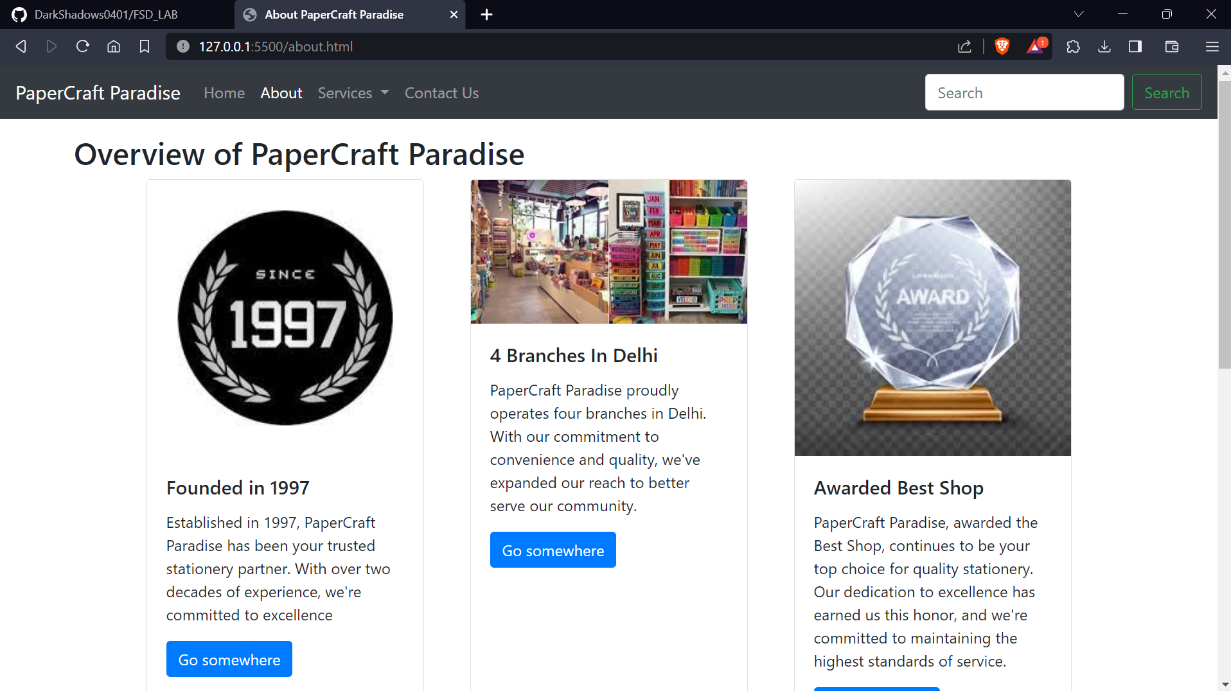

# Mobile-View

